PROJECT REPORT

Rule-Based Intelligent Agent for Stock Trading Decisions



Project Title Rule-Based Intelligent Agent for Stock Trading
Course Code CSA 2001
Course Title Fundamentals in AI/ML
Submitted By Yash Upadhyay
Register no. 25BAI10600
Date 24 March 2026

1. Abstract
This project presents a simple rule-based intelligent agent designed for stock trading decisions. The system reads stock price data day by day, calculates percentage change in price, and applies predefined rules to generate one of three actions: Buy, Sell, or Hold.

The main objective of the project is to demonstrate basic Artificial Intelligence concepts such as intelligent agents, rational decision-making, and environment interaction. A simple profit calculation is also included to evaluate the usefulness of the trading decisions.

This project is suitable for beginner-level AI learning and also connects with financial decision systems.

2. Introduction
AI, or artificial intelligence, is a subset of computer science that empowers systems to execute tasks generally needing human intellect. An AI can be described as an intelligent agent.
An intelligent agent observes the environment, interprets information and decides on actions to achieve a certain goal.
Here stock market price data acts as the environment for this project. A simple intelligent agent is created based on dedicated rules for taking trading decisions. The decision to Buy, Sell or Hold is made daily by the agent price changes.
The project demonstrates AI fundamentals and also reflects financial decision-making.

3. Problem Statement
Stock prices are constantly changing, and traders need to make a decision.
Problem Statement: The problem we are addressing here is to develop a simple intelligent agent that interacts and trades with the market without human intervention, simply by following predefined rules on stock price movement.
Objective: Implement AI ideas in a simple financial environment

4. Objectives
- To design a simple intelligent agent
- To simulate stock trading decisions
- To apply rational decision-making
- To calculate simple profit
- To connect AI concepts with finance

5. AI Concepts Used
Intelligent Agent
Because it observes stock price data and takes action, the system functions as an intelligent agent.
Rational Agent
Reinforcement learning: q-learning agent "The agent is rational because it acts on the basis of predefined rules."
Environment
The stock market serves as the habitat in which our agent lives.
Problem Solving
The agent tackles the decision problem of whether to Buy, Sell or Hold

6. Methodology
The project uses stock price data stored in a CSV file.
The system reads daily prices and calculates percentage change using:
$$\text{Percentage Change}=\frac{\text{Current Price}-\text{Previous Price}}{\text{Previous Price}}×100$$
The agent then applies simple rules:
- If price falls by 2% or more → BUY
- If price rises by 2% or more → SELL
- Otherwise → HOLD
If a BUY action is followed by SELL, then profit is calculated.

7. Algorithm
- Read stock price data
- Calculate percentage change for each day
- Apply decision rules
- Generate Buy / Sell / Hold action
- Store decisions
- Calculate profit when selling
- Display output
- Save result

8. Implementation
The program is written in Python using:
- csv
- matplotlib
The input file used is:
stock_data.csv
The output generated is:
output_table.csv
The graph visually shows:
- stock prices
- buy points
- sell points
9.Output and Testing examples
Example 1:
Day,Price
1,100
2,98
3,97
4,99
5,102
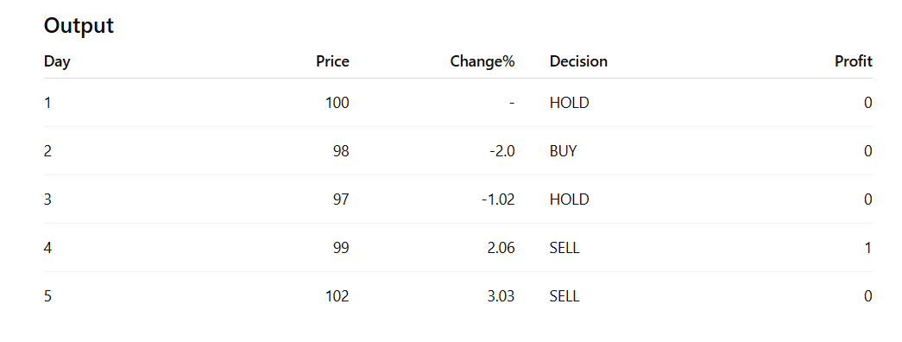
Example 2:
Day Price
1 120
2 117
3 115
4 118
5 121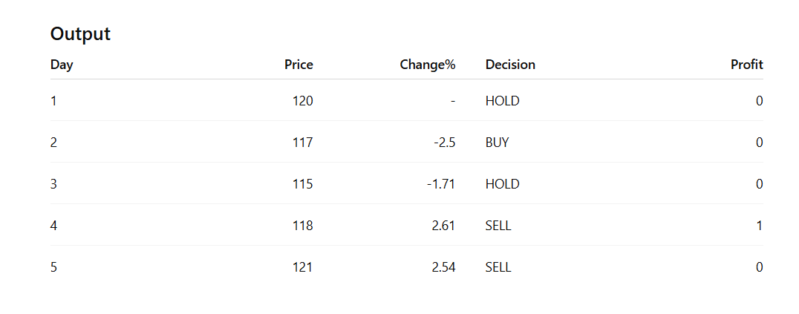
10. Result Analysis
The intelligent agent successfully generated trading decisions based on price movement.
The system was able to:
- identify buying opportunities during price drops
- identify selling opportunities during price rises
- calculate simple profit
This shows how rule-based systems can simulate basic financial decision-making.

11. Reflection
This project helped me understand how intelligent agents work in practical environments.
I learned that even simple rule-based systems can demonstrate rational decision-making clearly.
This project also helped me connect AI fundamentals with my long-term interest in quantitative engineering.

12. Conclusion
I gained an important experience from this project, as it was the first time I had worked with a clever artificial intelligence (AI) automated system in the real world to see how simple different types of AI intelligent agents operate. The program reads stock market prices, looks at how much they change and then based on defined rules to make a decision (buy, sell, hold).
By doing this project, I learned how AI concepts/developments like intelligent agent, rational decision-making and working in the physical environment can all come together in one easy example. In this case, the stock market is the physical environment and the intelligent agent makes its decisions based upon price movements (price changing).
Additionally, I also tabulate the profits generated by the intelligent agent so that I could evaluate if the intelligent agents actions were effective. Overall, this project helped me connect how concepts that I had learned in my Fundamentals of AI and ML course to a finance application that fits into my passion for quantitative engineering!

